Monday 25th January
MLJ is to write the end of the story and add wishes

Use the pictures to help you remember what to write.
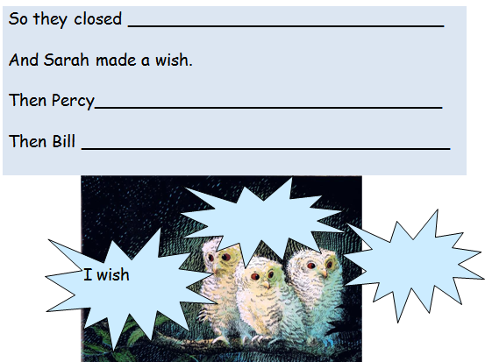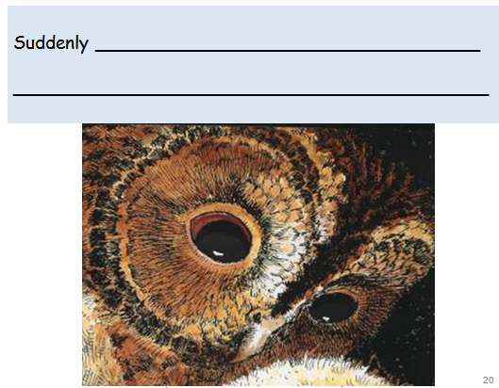
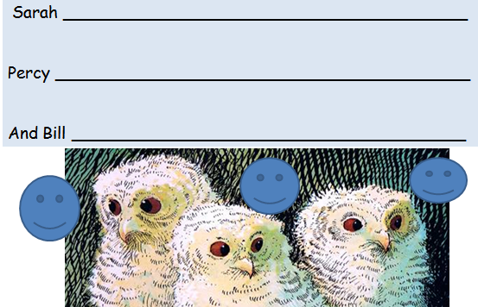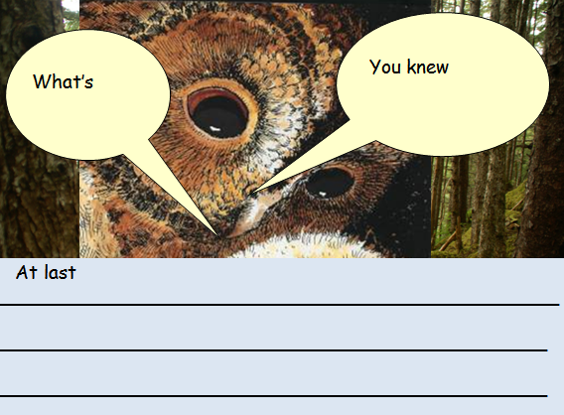
Don’t forget to use the connectives so suddenly at last
__________________________________________________________________________________________________________________________________________________________________________________________________________________________________________________________________________________________________________________________________________________________________________________________________________________________________________________________________________________________________________________________________________________________________________________________________________________________________________________________________________________________________________________________________________________________________________________________________________________________________________________________________________________________________________________________________________________________________________________________________________________________________________________________________________________________________________________________________________________________________________________________________________________________________________________________________________________________________________________________________________________________________________________________________________________________________________________________________________________________________________________________________________________________________________________________________________________________________________________________________________________________________________________________________________________________________________________________________________________________________________________________________________________________________________________________________________________________________________________________________________________________________________________________________________________________________________________________________________________________________________________________________________________________________________________________________________________________________________________________________________________________________________________________________________________________________________________________________________________________________________________

