Maths
Tuesday 19th January 2021 MLJ is to add numbers to 20 using my knowledge of number bonds
Task 1
Fill in the missing numbers - Use the number line to help you.
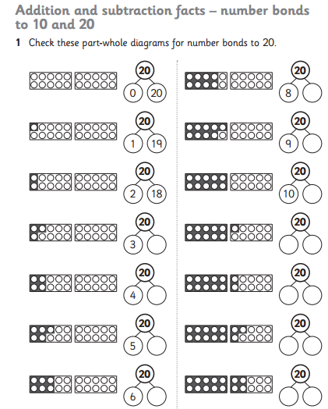
Fiery challenge!
Create some number sentences to 20 using the blank part whole models



