Tuesday 19th January 2020
MLJ is to write a story beginning

Use the pictures to write the beginning of the story. Only write about the first part of the story we discussed as we will do more tomorrow.
Here is the whole story map
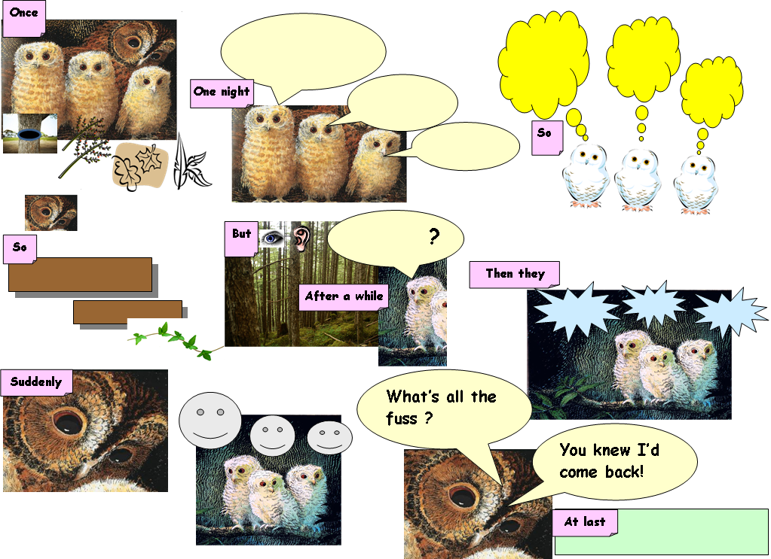

You only need to write about the first two pictures....
Your first sentence will start with the word – Once
Your second sentence will start with the words - One night
Once..._______________________________________________________________________________________________________________________________________________________________________________________________________________________________________________________________________________________________________________________________________________________________________________________________________________________________________________________________________________________________________________________________________________________________________________________________________________________________________________________________________________________________________________________________________________________________________________________________________________________________One_night__________________________________________________________________________________________________________________________________________________________________________________________________________________________________________________________________________________________________________________________________________________________________________________________________________________________________________________________________________________________________________________________________________________________________________________________________________________________________________________________________________________________________________________________________________________________________________________________________________________________________________________________________________________________________________________________________________________________________________________________________________________________________________________________________________________________________________________________________________________________________________________________________________________

