English
Friday 15th January 2021
MLJ is to write the end of the story
Your task today is to continue writing your story. You now know the end! You can add it to your writing from yesterday if you would like!
Remember you just use the pictures on the story map to help you
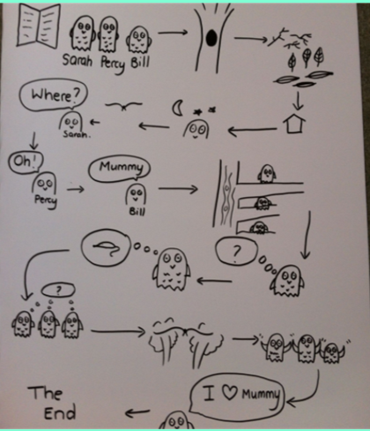

If you would like you can use this link to listen to the story being told – relax and enjoy!
https://www.youtube.com/watch?v=TPQRiSTYFHo

