Maths - Friday 15th January 2021
MLJ is to you your value of place knowledge to solve problems
Task 1
Sign on to Mathletics to have a go at the place value questions
Task 2
Have a go at the questions below
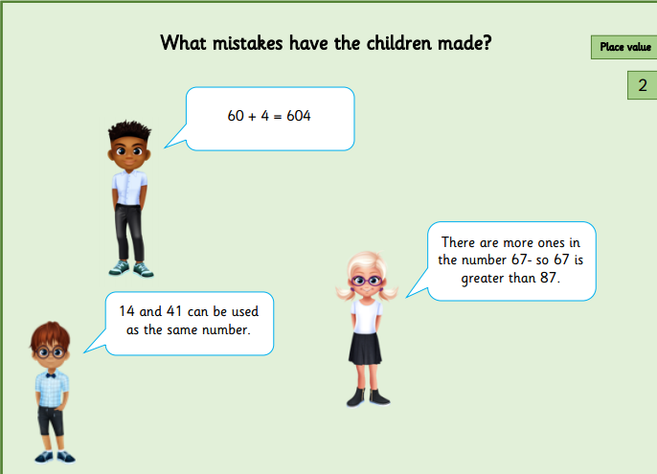

Can you explain your answer?
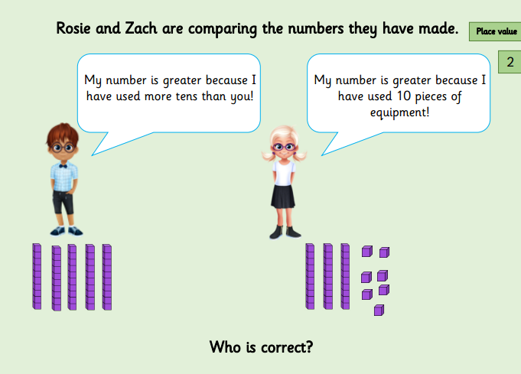
Explain your answer...

Fiery challenge!



