English
Thursday 14th January 2021
MLJ is to write the middle of the story
Your task today is to continue writing your story. You now know the middle! You can add it to your writing from yesterday if you would like!
Remember you just use the pictures on the story map to help you
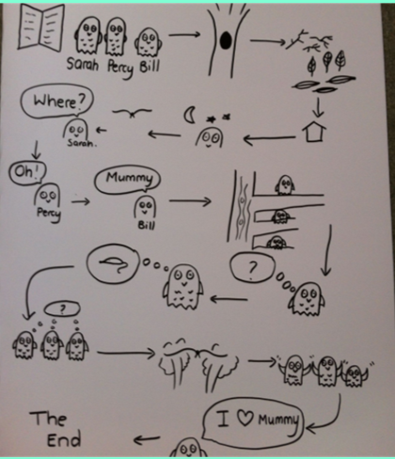

Have fun hedgehogs!

