05/03/21
MLJ: to recognise money by subtracting amounts to work out the change ?

Check your change from 20p.
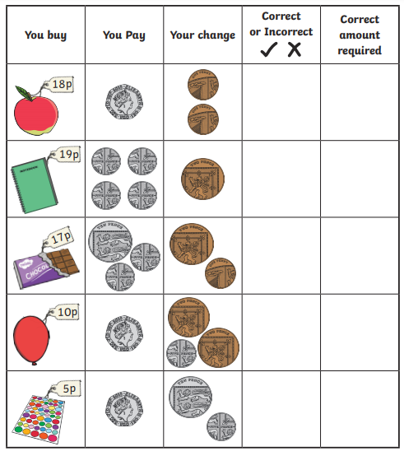

Red bubble challenge:


