02/03/21
MLJ: to recognise the value of coins up to £1 ?

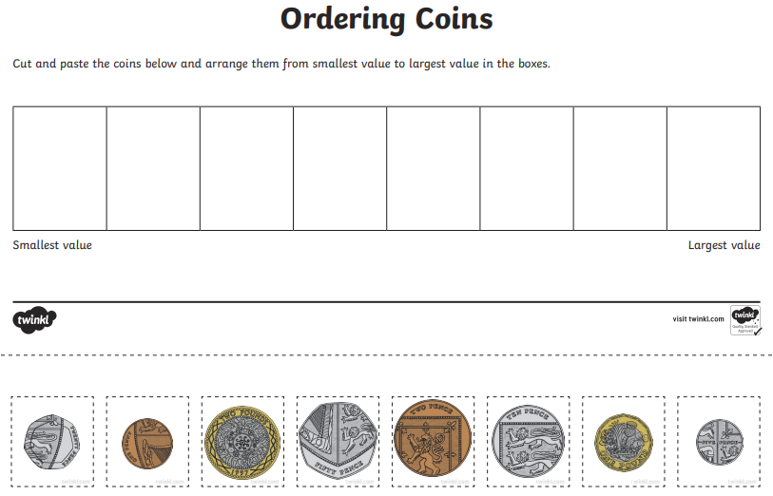

Red bubble challenge:
What have you noticed about the order of value of the coins?

