Homework and Remote Learning for Squirrels Class
Date: Monday 1st March 2021 |  | Date due: Friday 5th March 2021
Phonics = Compulsory (daily)  Phase 5b is about learning the alternative pronunciations of graphemes we have already learned.  This week:  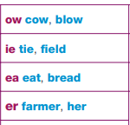  Phonics: revisit Phase 5 sounds  Tricky words: water, where, who, again, thought, through, work, mouse  https://www.phonicsplay.co.uk/resources/phase/5  Username: jan21  Password: home | Number bonds = Compulsory (daily)  Number bonds to 10: https://www.youtube.com/watch?v=pd2zVDrGHoc  Number bonds to 20:  https://www.youtube.com/watch?v=h6udqW6VhWg  Mathletics   Log into Mathletics and check the learning I have assigned for you. |  | Reading Task = Compulsory (daily)    Read daily (4x per wk) your scheme book.  Book changing day: Tuesdays 10am-12pm.
PE (Physical Education)  Miss Szary (our P.E. coach) has created a workout video for us to enjoy!  https://www.youtube.com/watch?v=9tvgzZO7baU  You can access more videos from here:  https://www.youtube.com/channel/UCwwFLMTsf6gO4WZaIf0jHoQ?app=desktop | Topic – History  Our new topic in History is learning about Mary Seacole.  MLJ: to explore the conflict that resulted in the Crimean war.  Use a dictionary to find what ‘war’ and ‘conflict’ means.  Watch: https://www.youtube.com/watch?v=2xS2yiwZPCw  https://www.youtube.com/watch?v=M6FJoTn_3L8  How did the Crimean war start? What did Mary Seacole do to help the soldiers?  Activity: research more information about what happened in the Crimean war. What did Mary Seacole do to help? You can write sentences or use drama to portray the events. Perhaps you could act how Mary would have been when helping the soldiers as she was a nurse. You can record and send to our Squirrels email! Include the key vocabulary; war, conflict, nurse etc. |  | Science  Our new topic in Science is about Seasonal Changes with the focus of Spring and Summer.  MLJ: to describe the weather associated with each season (Spring and Summer).  What do you know about Spring and Summer? What is the weather like today? What do you predict the weather will be like tomorrow? Why?  Watch: https://www.youtube.com/watch?v=VYpGBtR8Lbs  Activity: go outside and record the weather (see attached). How is the weather different from Autumn or Summer?  Create a piece of art with pieces of fruit or vegetables that are grown in Spring/Summer time such as; apples, peppers or carrots etc.  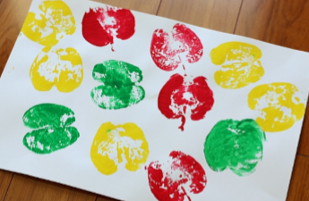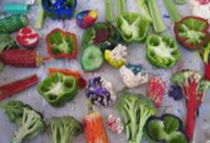
Art  Our topic in art is creating a piece of art in response to the famous abstract artist Piet Mondrian.  MLJ: to mix primary colours to make secondary colours.  The Colour song: https://www.youtube.com/watch?v=XqYUvzLcvyI  The primary colours song: https://www.youtube.com/watch?v=v9gIj0j7Ba0  Activity: Piet Mondrian used primary colours in his art (yellow, blue and red). What colours do you think you will make when you mix them together? Explore using paint (see attached)! | Music  We are learning about ‘pitch’  What are high sounds? https://classroom.thenational.academy/lessons/high-sounds-c4rp4e  What are low sounds? https://classroom.thenational.academy/lessons/low-sounds-65h3ed  Activity –  Can you create high and low sounds? Explain what high and low sounds are. |  | RE  Our new topic in R.E is learning about why Christians pray to God and worship him.  Christians show other ways of worship (other than prayer) such as through songs: https://www.youtube.com/watch?v=vdMIxCdlY-c  MLJ: to explore how Christians pray and worship.  Activity: Research what a prayer is and write it in your book.  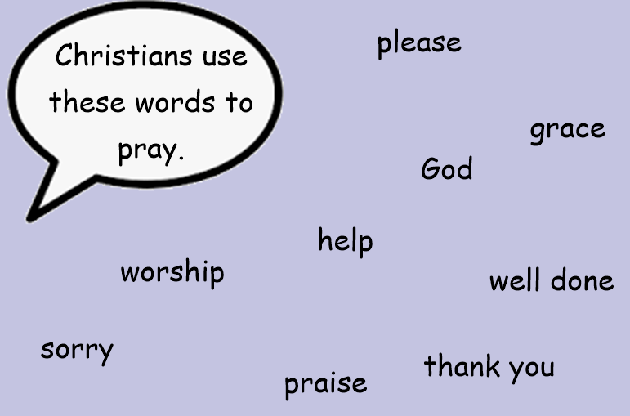  Write a sentence by including one of these words. Look at the images (attached) and explore what you notice.

Please send in learning to our class email: remotelearningsquirrels@beaumontschool.suffolk.sch.uk



