01/03/21
MLJ: to recognise coins up to £1 ?

Go on a coin hunt! Have you got any coins in your piggybank or purse? Have your grown-ups got any coins you can borrow?

Using the coins you have found, write the correct amounts for each coin.
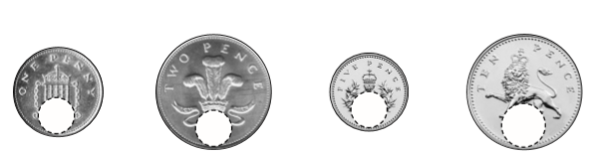
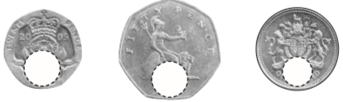

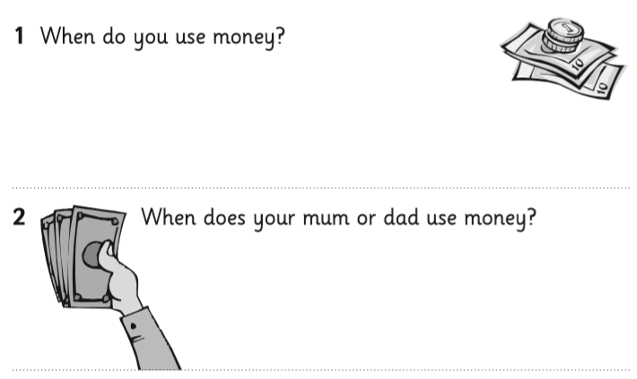

Red bubble challenge:
- Put the coins you found in size order. What do you notice?

- What is the amount for this coin?


