Tuesday 23rd February 2021
MLJ: to write sentences by writing the features of non-fiction texts ?
I can see…
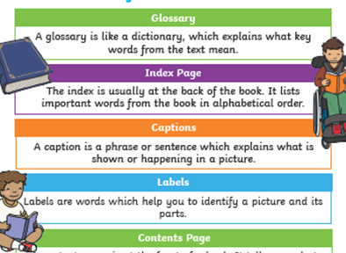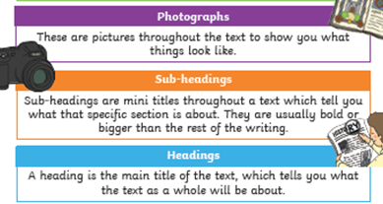

____________________________________________________

____________________________________________________

____________________________________________________

____________________________________________________

Red bubble challenge:
What does ‘non-fiction’ mean?

________________________________________

