23/02/21
MLJ: to identify place value (20 and beyond) using dienes ?

Cut and match the number to the dienes and place value.

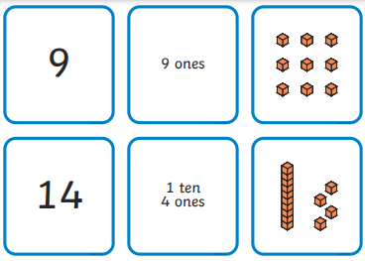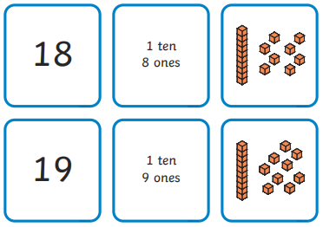
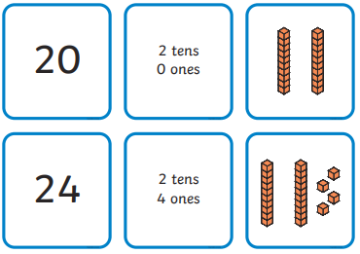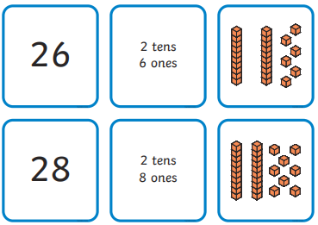

Match the number of dienes to the place value:


