 | Monday | Tuesday | Wednesday | Thursday | Friday
Phonics | MLJ: to read the tricky words ‘were there little one’.  Task: to read and write the words. Practise handwriting. | MLJ: to read tricky words.  Task: Practise reading and writing Phase 4 tricky words (see attached). | MLJ: to spell words.  Task: write 5 lettered CCVCC (consonant, consonant, vowel, consonant, consonant) words, such as crept, think, drift etc. | MLJ: to spell tricky words.  Task: Practise reading and writing ‘my all her.’ Practise handwriting. | MLJ: to recap what we have learned this week.  Task: go through phase 4 words by practising to read and write them. Practise handwriting. Practise writing CCVCC words – become confident with sounding out sounds to spell it, eg, brick, trash, drink etc.
Eng | MLJ: to order the story.  Task: use the pictures (see attached) to order the story or you could draw the pictures. Challenge: add captions to the pictures – what happened in the story? | MLJ: to retell the story.  Task: Using your learning from yesterday, retell the story. You can retell it orally or write sentences to retell it. | MLJ: to learn about rhyming words.  Task: think of some words that rhyme with ‘pin’ or ‘fan.’ Find the rhyming words from the book and write them down. You can access the story from: https://www.youtube.com/watch?v=cfiPrA8E3qE What do you notice about the spelling? What they sound like? | MLJ: to use drama to retell parts of the story.  Task: Recap – what are rhyming words? Did you find them in the book? Use drama to act out the scenes where the animal has a problem and the giant helps them out. For example, the goat has a problem with his boat! The giant helps by giving his shirt for a new sail. | MLJ: to write sentences by writing about the problems in the story (giraffe).  Task: write sentences by writing about giraffe’s problem. Sentence starter: “It’s my….I wish I had….” Challenge: include more than adjective to describe the problem.
Maths | MLJ: to find out one more (within 50).  Task: to understand what ‘more than’ means, eg, add, addition, plus etc. Here is the youtube link for ‘more than’: https://www.youtube.com/watch?v=Du6JHupzwVo Solve ‘more than’ questions, eg “1 more than 3 = ?”. You could challenge yourself to work out one more than any number up to 50. | MLJ: to find out one less (within 50).  Task: to understand what ‘less than’ means, eg, take away, subtract, minus etc. Here is a youtuibe link for ‘less than’: https://www.youtube.com/watch?v=D3b-kcK3Eg8 Solve ‘less than’ questions. Eg, “1 less than 4 = ?”. You could challenge yourself to work out one less than any number up to 50. | MLJ: to recognise numbers in ‘teen’ numbers.  Task: to know what ‘teen’ numbers are; eg, 13, 14 15 etc. Place value is understanding the tens and ones of a number (eg, 14 = 1 ten and 4 ones). Here is a youtube link to help explain place value: https://www.youtube.com/watch?v=1F3AycEDksY Work out place value of 2 digit numbers, begin with ‘teen’ numbers. You could challenge yourself to work out the place value of numbers up to 50. | MLJ: to answer missing number problems (eg 10 + 4 = ? or 10 + 7 = ?).  Task: practise counting in 2s and 10s forwards and backwards. Recap what place value means and work out the place value of ‘teen’ numbers (or challenge: up to 50). Answer questions such as; 10 + 3 = ? or 10 + 7 = ? Understanding place value will help you work this out. | MLJ: to answer missing number problems (eg 14 = 10 + ? or 17 = 10 + ?).  Task: practise counting in 2s and 10s forwards and backwards. Recap what place value means and work out the place value of ‘teen’ numbers (or challenge: up to 50). Answer questions such as; 14 = 10 + ? or 17 = 10 + ? Understanding place value will help you work this out.
Science | MLJ: to find different habitats and describe how they are suitable.  Task: to understand what habitats (see attached) and invertebrates are (mini-beasts). Watch this video about invertebrates: https://www.bbc.co.uk/bitesize/clips/z44g9j6 . Can you think of any special places (habitats) that creatures live in? For example, rabbits live in burrows, crabs in rock pools and birds in nests etc. Go outside and hunt for some invertebrates: what do you think you will fine? Where? See attached for checklist.
P.E. |  | MLJ: to jump and land with control and balance.  Task: You are going to be bouncing bunnies! Bounce on two feet, bend your ankles, knees and hips and use your arms to propel. Can you bounce on the spot? Forwards and backwards? Use different equipment safely?  Youtube is a great place for exercise ideas!: https://www.youtube.com/watch?v=c_MYrvoo0qY  You can follow Joe Wicks too!
Music |  |  |  | MLJ: to make long and short sounds using instruments.  Task: if you have an instrument, can you make long and short sounds? You could make your own instrument by filling an old water bottle with rice and decorate it. Voila – your own maraca! You could turn it upside down slowly to make a long sound and shake it quickly to make short sounds.
Topic |  |  | MLJ: to name the seven continents and five oceans.  Task: this explains the seven continents: https://www.youtube.com/watch?v=K6DSMZ8b3LE  This explains the five oceans: https://www.youtube.com/watch?v=X6BE4VcYngQ Learn the song to help you remember what the seven continents and five oceans are. Label and colour the continents and oceans (see attached). Challenge: can you order and write the continents from smallest to biggest?
Art |  |  |  |  | MLJ: to use cutting and shaping techniques.  Task: use your playdough that you created last week. Can you cut it with different tools? Such as a ruler, lollypop stick, cutlery, rolling pin, cookie cutters etc. Which technique did you prefer? Why?  Did you enjoy ‘dough disco? Here’s another: https://www.youtube.com/watch?v=o9D5lfqZF3o

Resources:
Monday: English:

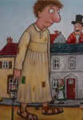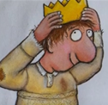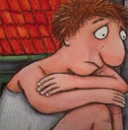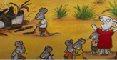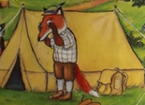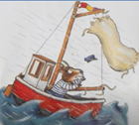

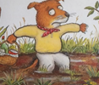

Science:
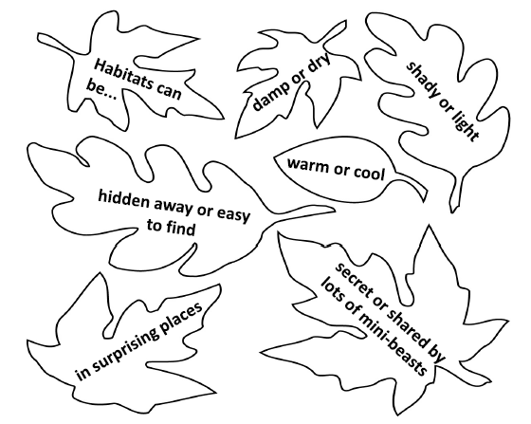
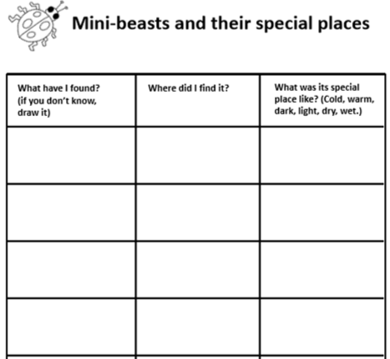

Tuesday: Phonics:
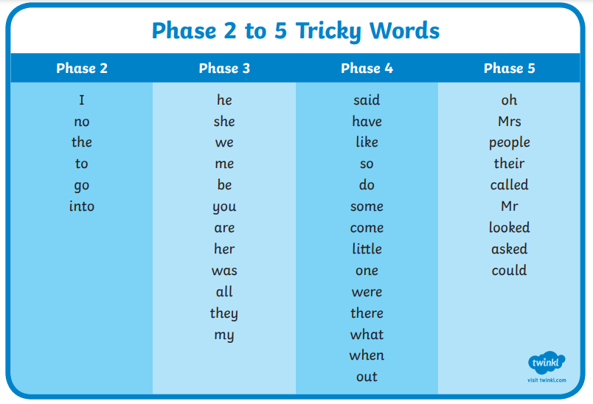

Wednesday: Topic


