10/02/21
MLJ: to recognise 3D shapes in different orientations in everyday objects ?
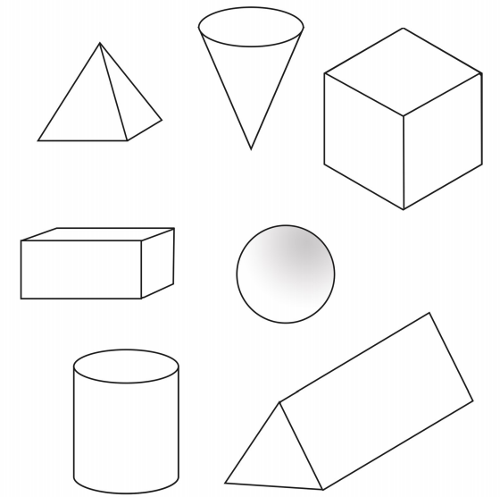
Cone

Cube

Pyramid

Cuboid
Prism

Sphere

Red bubble challenge:



