Monday 25th January 2021
MLJ: to invent a new story by writing about the characters (The Hungriest Giant in Town) ?
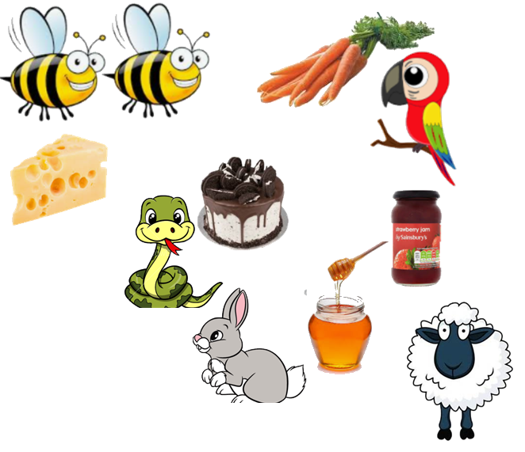

____________________________________________________

____________________________________________________

____________________________________________________

____________________________________________________

____________________________________________________
Red bubble challenge:
To include adjectives to describe the food. For example: Snake with a chocolate and sweet cake.

