Homework and Remote Learning for Squirrels Class
Date: Monday 25^{h} January 2021 |  | Date due: Friday 29th January 2021
Phonics = Compulsory (daily)  Click on the link below to learn the new sounds and tricky words.  Phonics: oy ir ue aw  Tricky words: Mr Mrs looked called asked  https://www.phonicsplay.co.uk/resources/phase/5  Username: jan21  Password: home | Number bonds = Compulsory (daily)  Number bonds to 10: https://www.youtube.com/watch?v=pd2zVDrGHoc  Number bonds to 20:  https://www.youtube.com/watch?v=h6udqW6VhWg  Mathletics   Log into Mathletics and check the learning I have assigned for you. |  | Reading Task = Compulsory (daily)  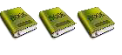  Read daily (4x per wk) your scheme book.  Book changing day: Tuesdays 10am-12pm.
PE (Physical Education)  Have a go at Cosmic Yoga:  https://www.youtube.com/watch?v=ISX9DSK4uEk  Just dance:  https://www.youtube.com/watch?v=CyfM2o0d0IE | Topic - Geography  To know what an ocean is.  https://classroom.thenational.academy/lessons/what-is-an-ocean-crrp6e  Activity – in your book, write what an ocean is. Can you name all five? Complete the quiz. |  | Science  To know what types of food living things eat.  https://classroom.thenational.academy/lessons/what-types-of-food-do-living-things-eat-c4wkje  Activity – in your book, draw pictures of different animals and why they eat. Complete the quiz.
Art  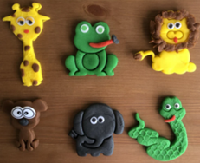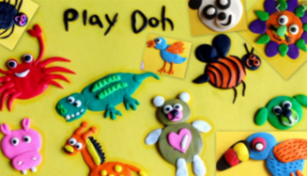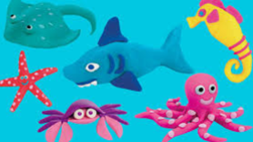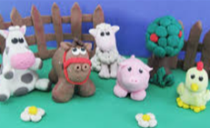  Draw a picture of an animal that you would like to create Think about:  - Which animal  - Why you are choosing that animal  - Colour  - Shape  Use the remote learning email to share your pictures | Music  High and low sounds.  https://classroom.thenational.academy/lessons/high-and-low-sounds-c9hk4e  Can you make your voice go high and low? Can you use instruments to make sounds that are high and low? |  | R.E  Parables are stories that Christians believe Jesus told to teach His followers.  One of Jesus’ parables is called The Lost Sheep. It teaches about God’s love, patience and forgiveness.  https://www.youtube.com/watch?v=tyWZeOlaRo4  What did you learn from this story? Write some sentences to explain what the story is about. You could draw a picture to illustrate the story.  You are the shepherd:  https://www.youtube.com/watch?v=3H01rTZhiyw  Can you sing along?

