2.3.21
MLJ is to convert between units of length ? (Year 5)

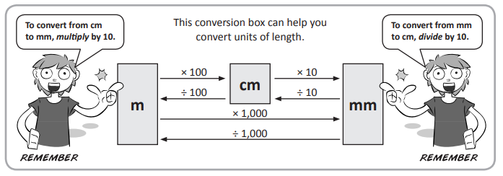

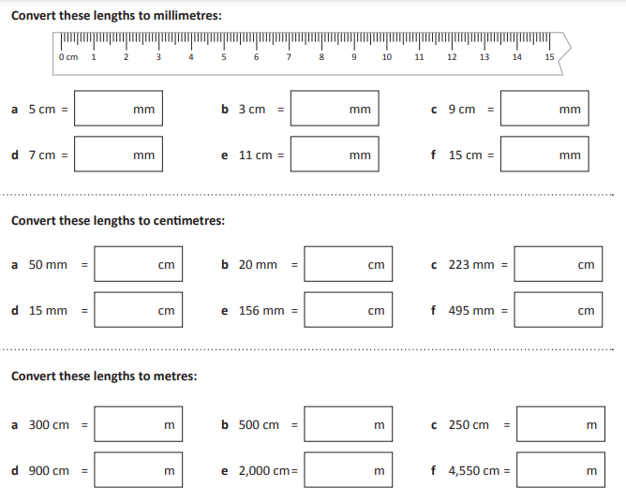
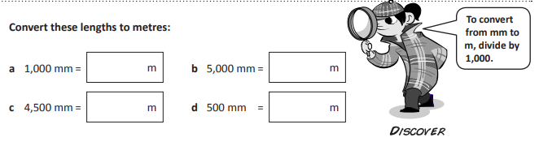

Red Hot Challenge

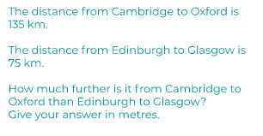

https://classroom.thenational.academy/lessons/decimals-and-measures-convert-standard-lengths-60tkad

