1.3.21
MLJ is to solve problems involving scale factors ? (Year 6)

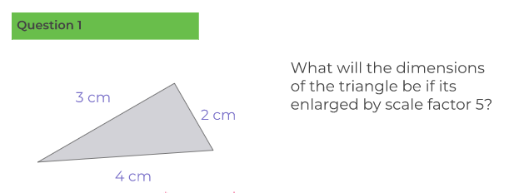

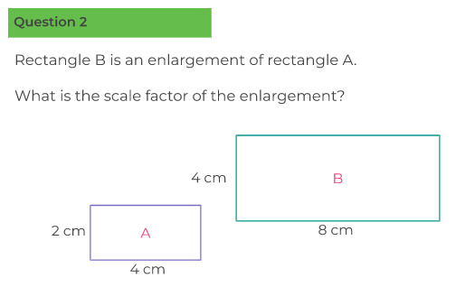

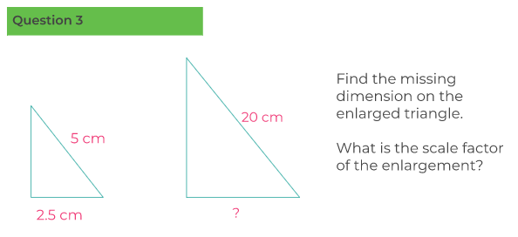

Red Hot Challenge

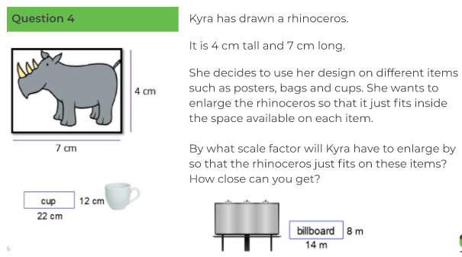

What is the perimeter of the original rectangle (4cm width and 7cm length)?
What is the area of the original rectangle?
When you enlarge it, what will the new perimeter and area be for the rhinoceros to fit in? Use the scale factor to help you calculate.

