8.2.21 MLJ is to use formal written methods of short division ? (Year 5)

https://www.bbc.co.uk/bitesize/topics/z36tyrd/articles/zgxdfcw

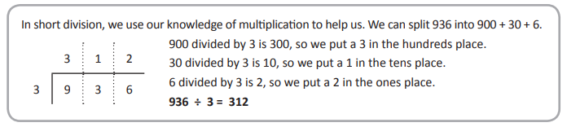
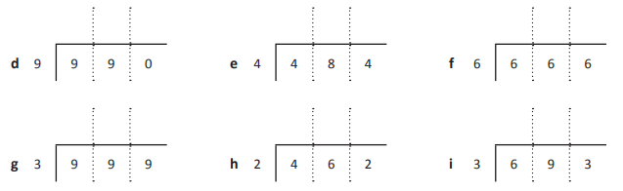
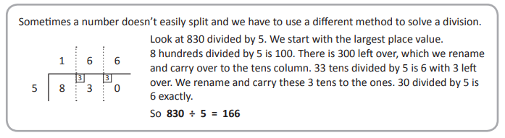
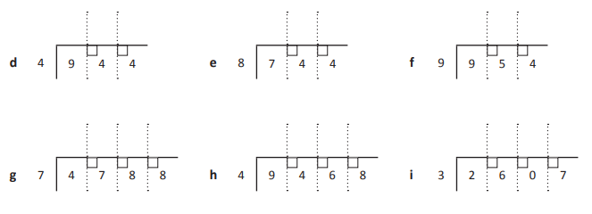
RED HOT CHALLENGE – solve the problem
Four friends find £936 in the street. They take it to the police but no-one claims it and the money is eventually returned to them to keep. If they share it fairly, how much do they each get?

