8.2.21 MLJ is to use formal written methods of short division ? (Year 6)

https://www.bbc.co.uk/bitesize/topics/z36tyrd/articles/zgxdfcw

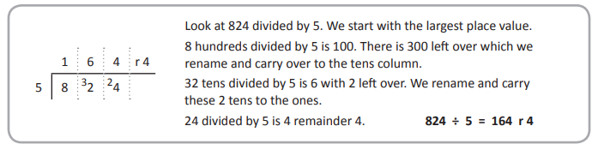

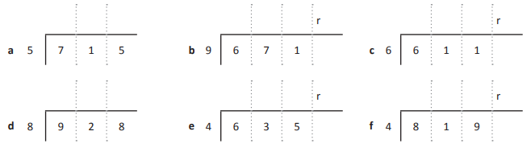

RED HOT CHALLENGE
Solve these problems?


