20.1.21 MLJ is to add and subtract decimals using mental strategies ? (Year 6)
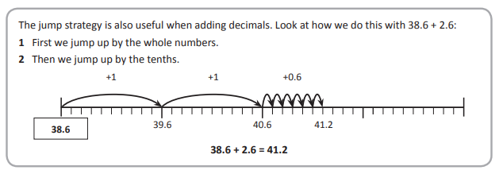
Jump Strategy

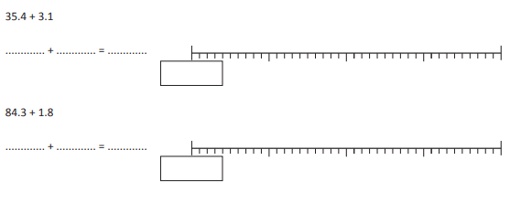
1. 73.7 + 2.8 =

2. 59.6 + 5.7 =

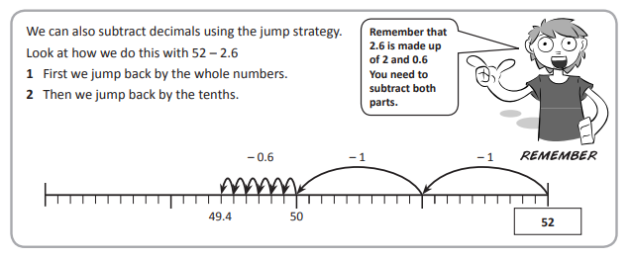

1. 93.2 – 3.7 =

2. 84.3 – 4.8 =

RED HOT CHALLENGE:


