19.1.21 MLJ is to subtract using mental strategies ? (Year 6)
Jump Strategy (using a number line)

Split Strategy (partition the number and then subtract)

Rounding and adjusting (round to the nearest 10 and adjust by 1 or 2 as needed)

1. Work these out using jump strategy
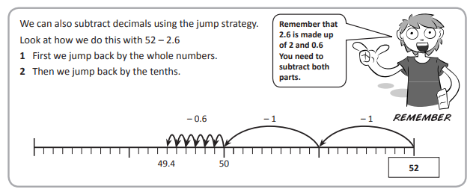
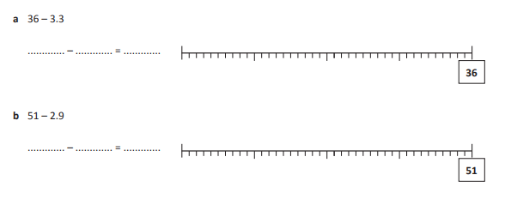
2. Use split strategy to solve these:
a) 421 – 153 = b) 632 – 138 =

3. Use rounding and adjusting to solve these:
a) 725 – 39 = b) 293 – 61 =

RED HOT CHALLENGE:
Work out the answers to these sums using jottings only.
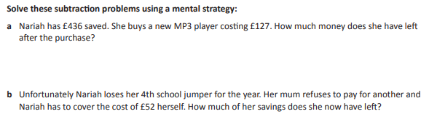
c

