Stockholm, Sweden

Latitude: 59.33 Longitude: 18.05

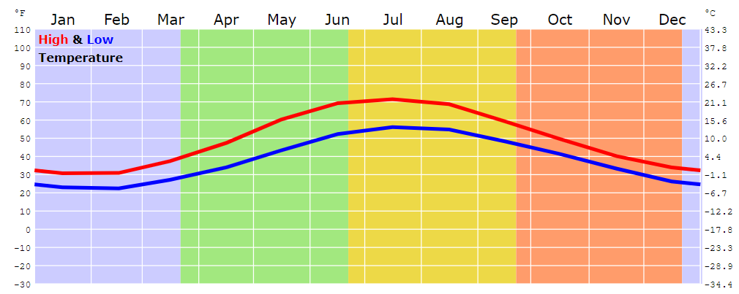

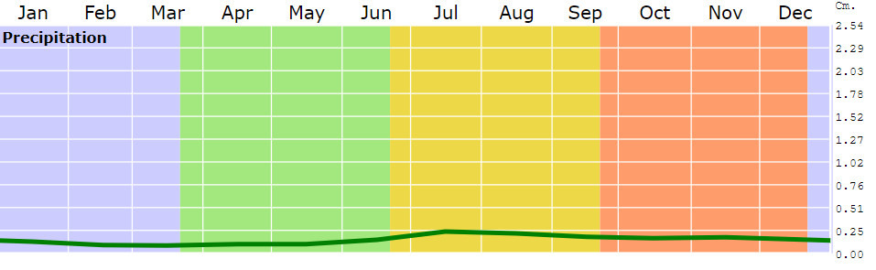

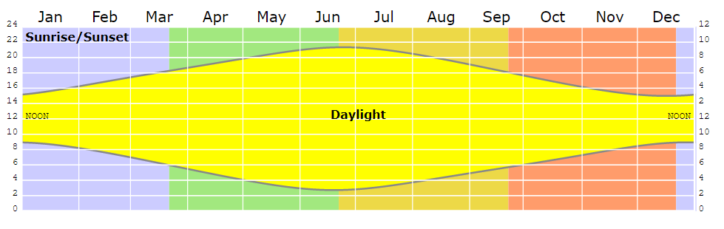

London, United Kingdom

Latitude: 51.15 Longitude: -0.18
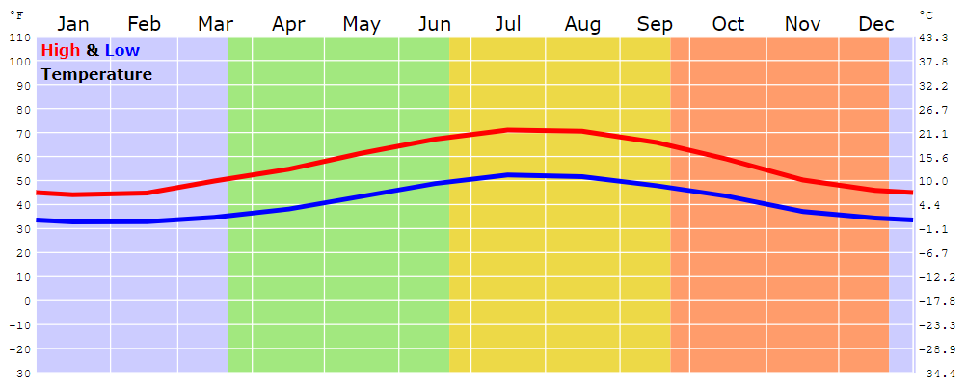

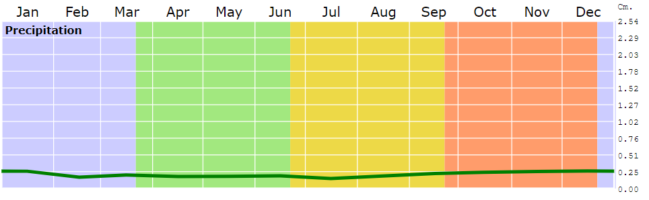

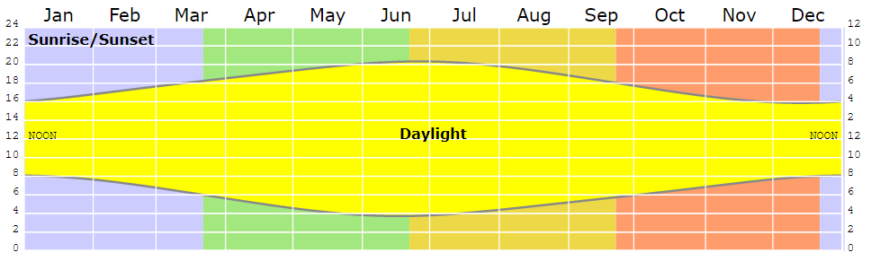

Brasilia, Brazil

Latitude: -15.78 Longitude: -47.93



