18.1.21 MLJ is to recognise that living things produce offspring of the same kind.
Task 1: Sort the following characteristics into inherited or environmental

Eye colour | Tanned skin from the sun | Hair colour
Language | General Health | Ear Lobes
Nose shape | Scar from an accident | Height
Sporting ability | Tongue rolling | Blood group
Intelligence | Weight | Migraines

Task 2: Can you use the following information to predict some possible characteristics of their children. I have completed the first suggestion for you.

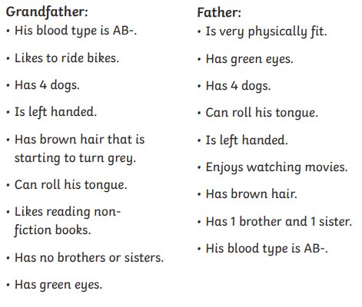
A son is likely to have brown hair because both the father and grandfather had brown hair.

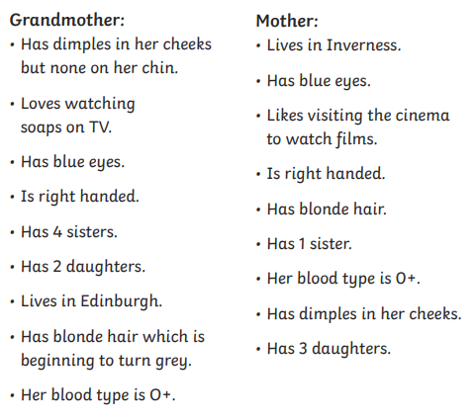
The daughter is likely to have blonde hair because both the mother and grandmother had blonde hair.

