18.1.21 MLJ is to add using mental strategies ? (Year 6)
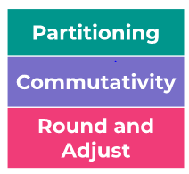
Work out the answers to these sums using jottings only.
eg partitioning: 52 + 31 = 50 + 30 = 80 = 83
2 + 1 = 3

eg commutativity: 17 + 41 + 3 = 20 + 41 = 61
(17 + 3 = 20 number bonds to 10)

eg rounding and adjusting: (+1) 49 + 13 = 62 (-1)
50 + 13 = 63

(-1) 41 + 23 = 54 (+1)
40 + 23 = 53

1. Show 2 different ways to solve this addition (show your jottings)


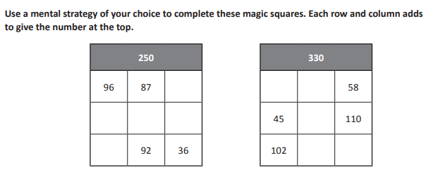

RED HOT CHALLENGE:
Work out the answers to these sums using jottings only. (Watch out for the decimals)


