Thursday 14th January 2021
MLJ is to write a suspense paragraph
Success Criteria
·Use short punchy sentences
·Use scary description
·Use repetition
·Use some personification
·Hide the scary thing
·Use one word sentences
·Use powerful verbs
·Add a simile
·Ask the reader a question
·Add the characters' description
·use ellipsis (...)
·Put an adverb at the beginning of a sentence

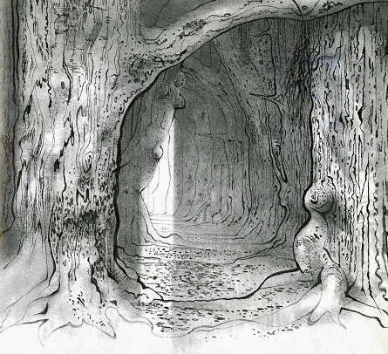

Filled with horror and dread, he pushed aside a tangle of briars and brambles.

