14.1.21 MLJ is to interpret and use negative numbers (Year 6)

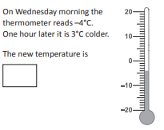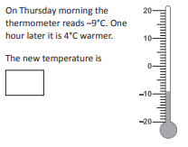
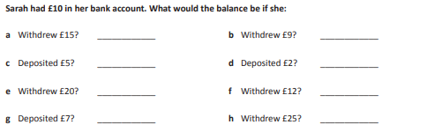
RED HOT CHALLENGE: Look at the graph on the next page and answer the questions.


