12.1.21 MLJ is to compare and order numbers (Year 5)

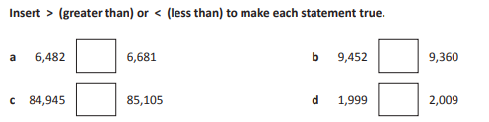

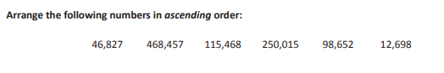

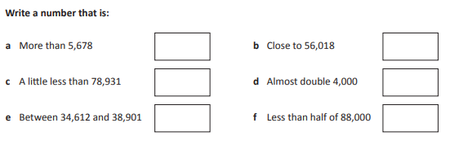

RED HOT CHALLENGE:
Complete the problems on the next page



