12.1.21 MLJ is to compare and order numbers (Year 6)

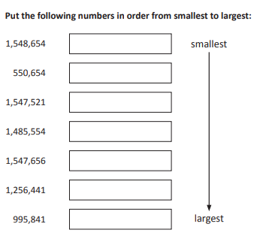

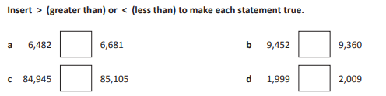

RED HOT CHALLENGE:
Complete the problems on the next page


