6.1.20 MLJ is to measure angles
Use your protractor to measure these angles. Use your spets to success sheet to help you.
Remember to record your answer in degrees (eg 35°)
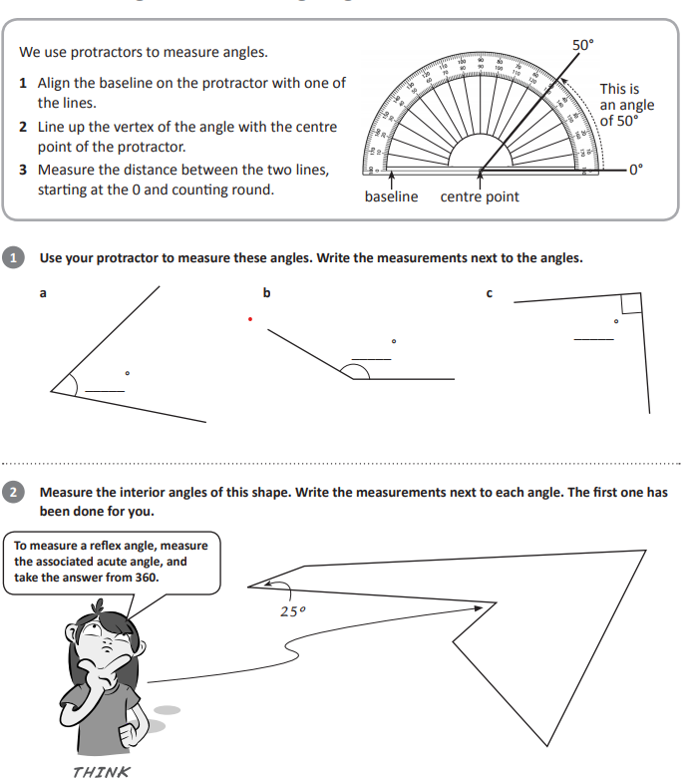
https://www.mathsisfun.com/geometry/protractor-using.html

Use this interactive online resource to practice measuring angles if you don’t have a protractor

