 | Phonics/Literacy | Maths
Monday | Children do some research into dinosaurs using dinosaur fact cards and websites. Record notes to help begin your dinosaur fact files later in the week.  https://www.nhm.ac.uk/discover/dino-directory.html  https://www.bbc.co.uk/cbeebies/topics/dinosaurs | Children get different objects from around the house and weigh objects (if you have scales at home)  Children sort objects into heavy and light.  Send photos

Activity

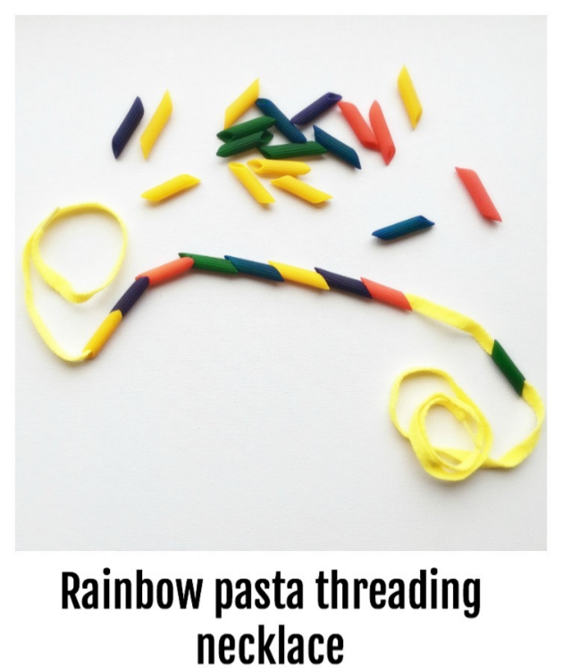

Make a pasta necklace to practice your fine motor skills.

