5/3 MLJ is to solve one step word problems involving addition and subtraction
MAIN ACTIVITY - in contexts of money to £1 e.g. shopping problems


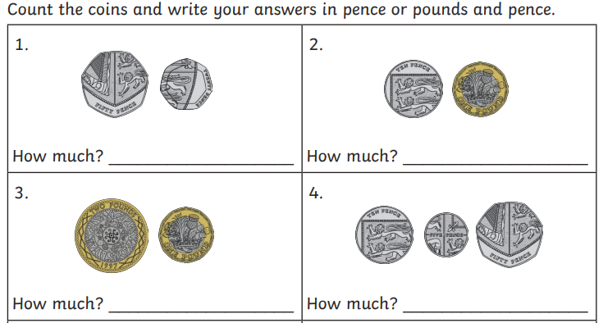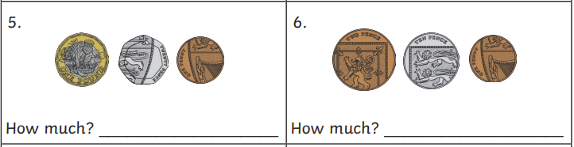
Fiery challenge


