Thursday 4th March 2021
MLJ is to find different combinations of coins that equal the same amount of money ?

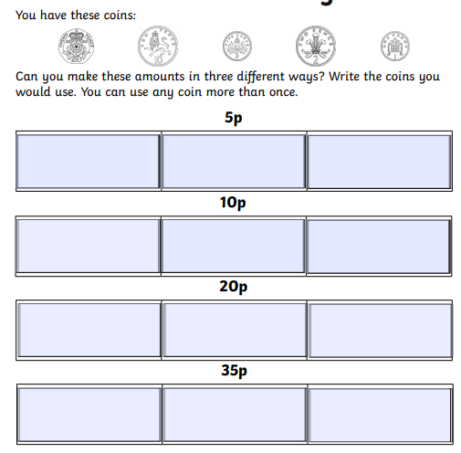

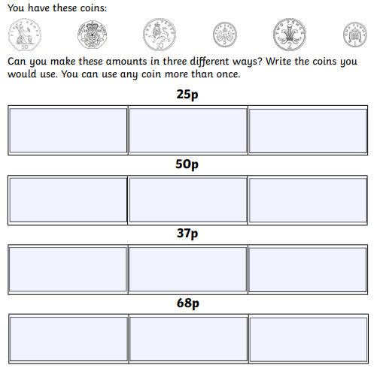
Fiery challenge
Fill the purses with coins to make the correct amount


