Tuesday 2nd March
MLJ is to tell the time to the nearest five minutes
Task 1 – complete the answers
- How many minutes are in 1 hour? _____
- How many hours are in a day?_____
- How many days in a week? ______
Task 2 – complete the times past the hour correctly
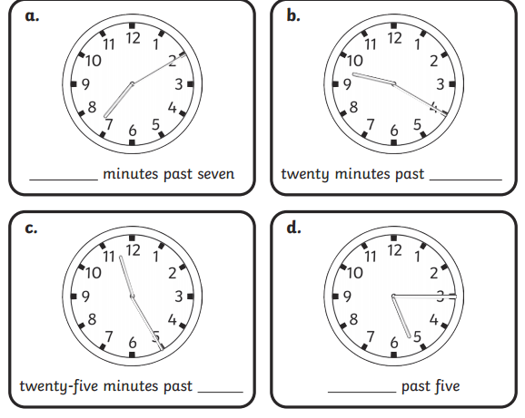

Task 3 – is to complete the times to the hour correctly
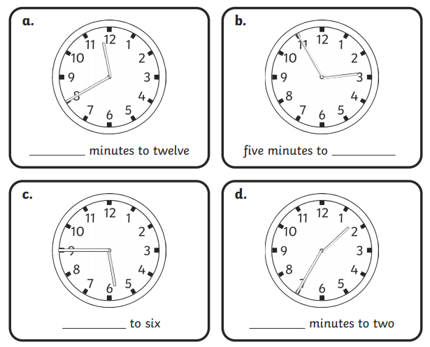
Finally – can you add the hands to the clocks to show the correct times?
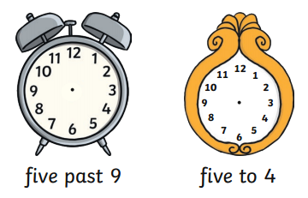
Fiery questions!


