Friday 25th february 2021
MLJ is to solve 2d and 3d shape problems ?

Name the shapes and then colour the correct 3d shape on the house!

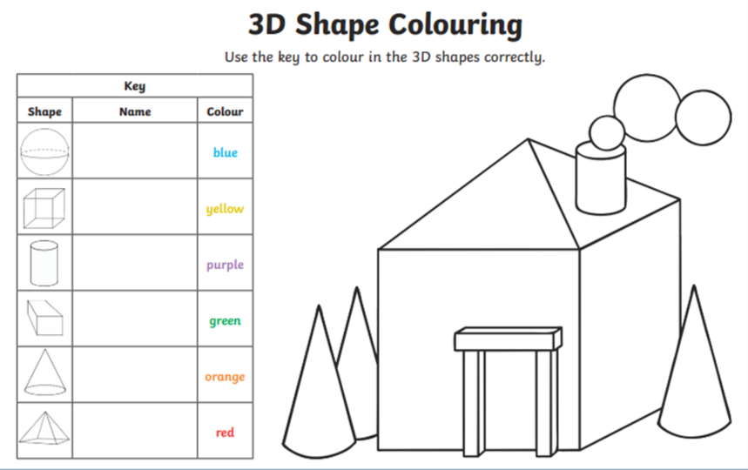

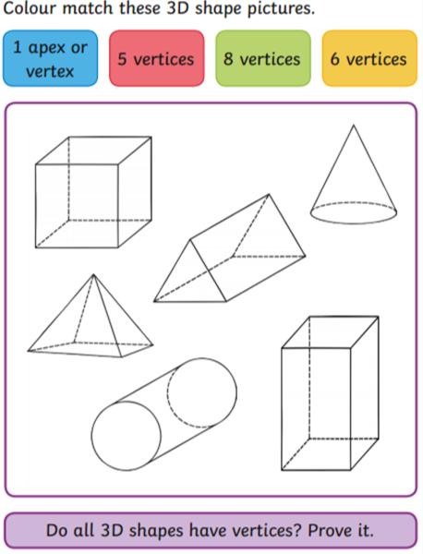

Perhaps you could try to draw the shape to help you?!
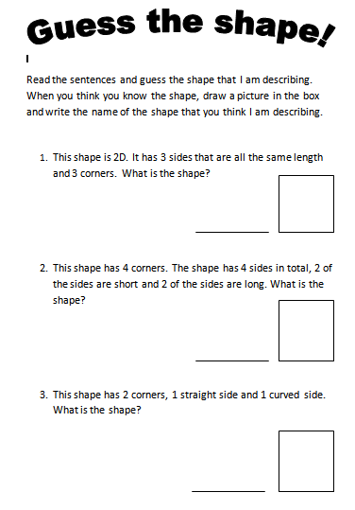
Fiery challenge!
Can you answer the questions about the shapes in the boxes below?

