Is this an old device or a new device?

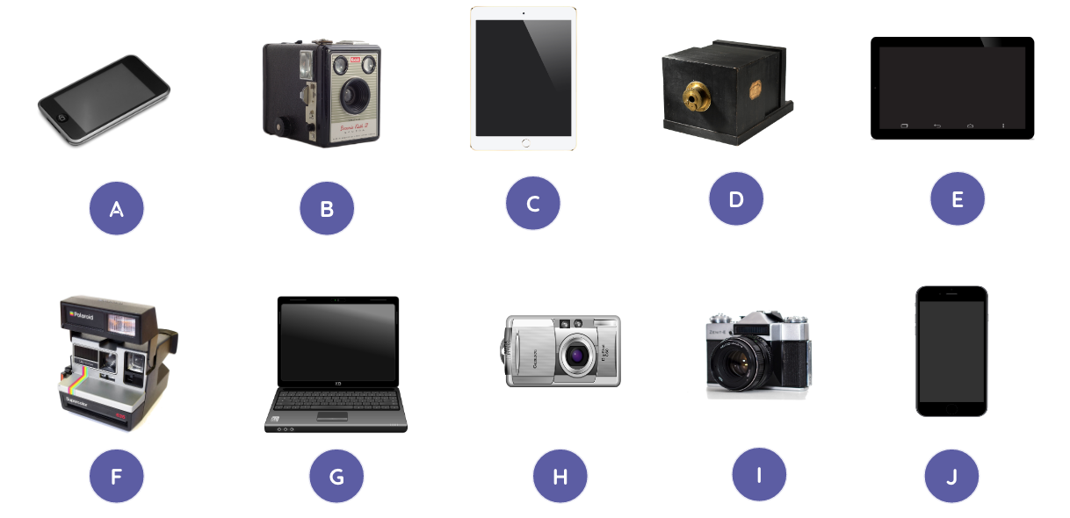
Sort these devices into old and new. You can either cut out and stick each picture on the table on the next sheet, write the matching letter, or write the name of the device if you know it.

Old devices | New devices

This resource is available online at ncce.io/cm2p-1-a1-w. Resources are updated regularly — please check that you are using the latest version.
This resource is licensed under the Open Government Licence, version 3. For more information on this licence, see ncce.io/ogl.

