Monday 22nd february 2021
MLJ is to identify and describe 2d shapes

Task one – follow the link and have a go at the Carroll diagram tasks
https://www.topmarks.co.uk/carroll-diagrams/2d-shapes

Task 2 – Complete the venn diagram below
Cut out or draw the shapes where you think they should go in the diagram.

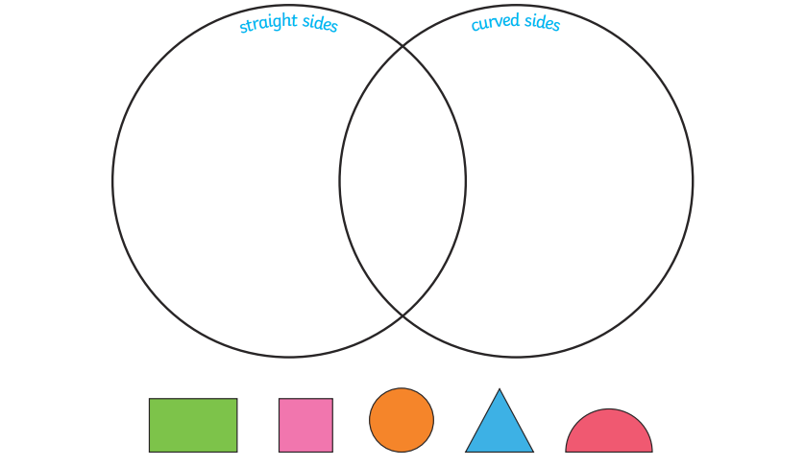

We worked on lines of symmetry, vertices before christmas. Can you fill in the chart below. The shapes are below so you can check the line of symmetry!

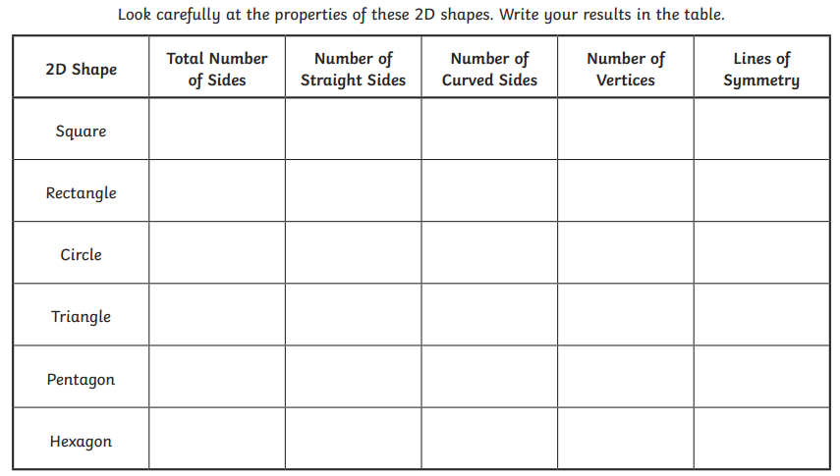

Fiery challenge!



