Friday 12th February 2021
MLJ is to solve one -step division word problems using arrays

1.
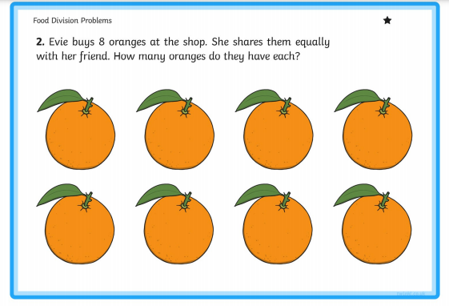

What is the ÷ number sentence here?

______________________________________

2.
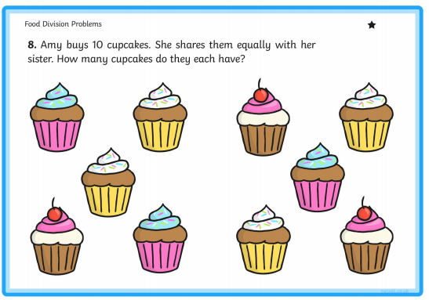

What is the ÷ number sentence here?

___________________________________

Fiery challenge
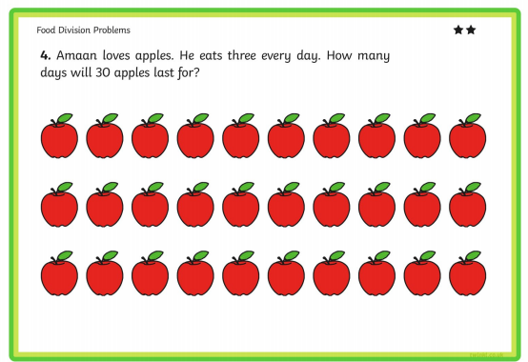
What is the ÷ number sentence here?
_______________________________________
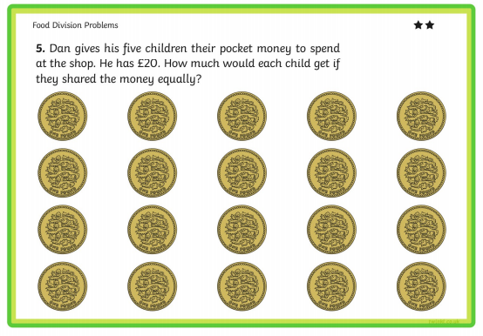
What is the ÷ number sentence here?
Super fiery challenge!


